**PyCharm On Remote Host Tutorial**

1. Click configuration

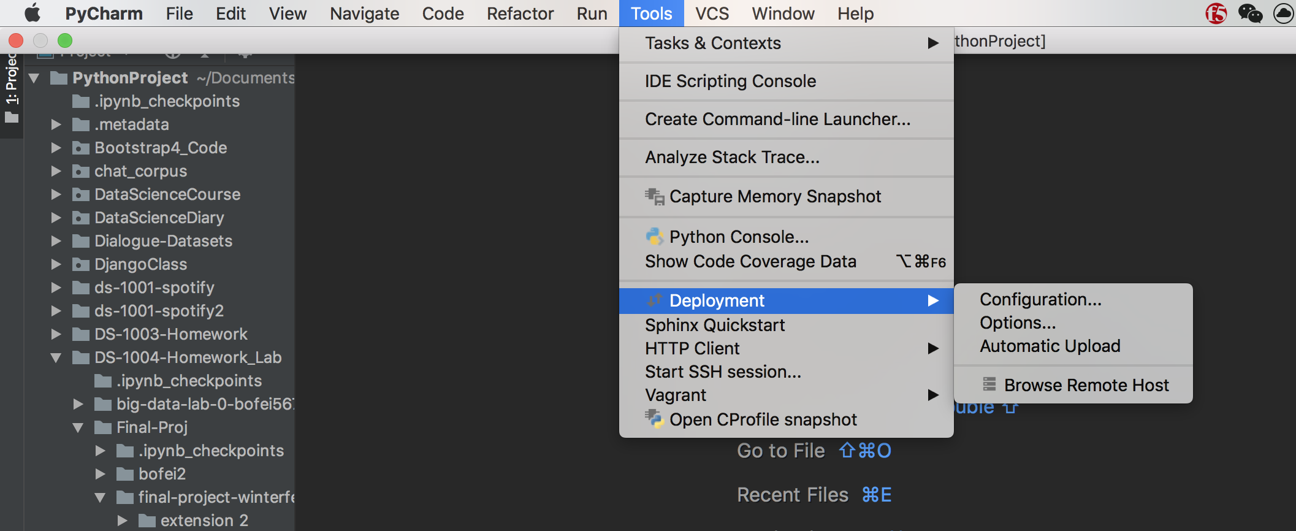

1. Click “+” sign, select “SFTP”, give a name for the server, fill the following boxes:

* Type: SFTP
* Host: skynet.nyumc.org (address for ssh)
* User name: your net id (user name for ssh)
* Password: password for ssh
* Root path: the directory path you see when login (you can change to the directory under your name)
* Webserver URL: http://skynet.nyumc.org
* Click Test Connection to see if it works

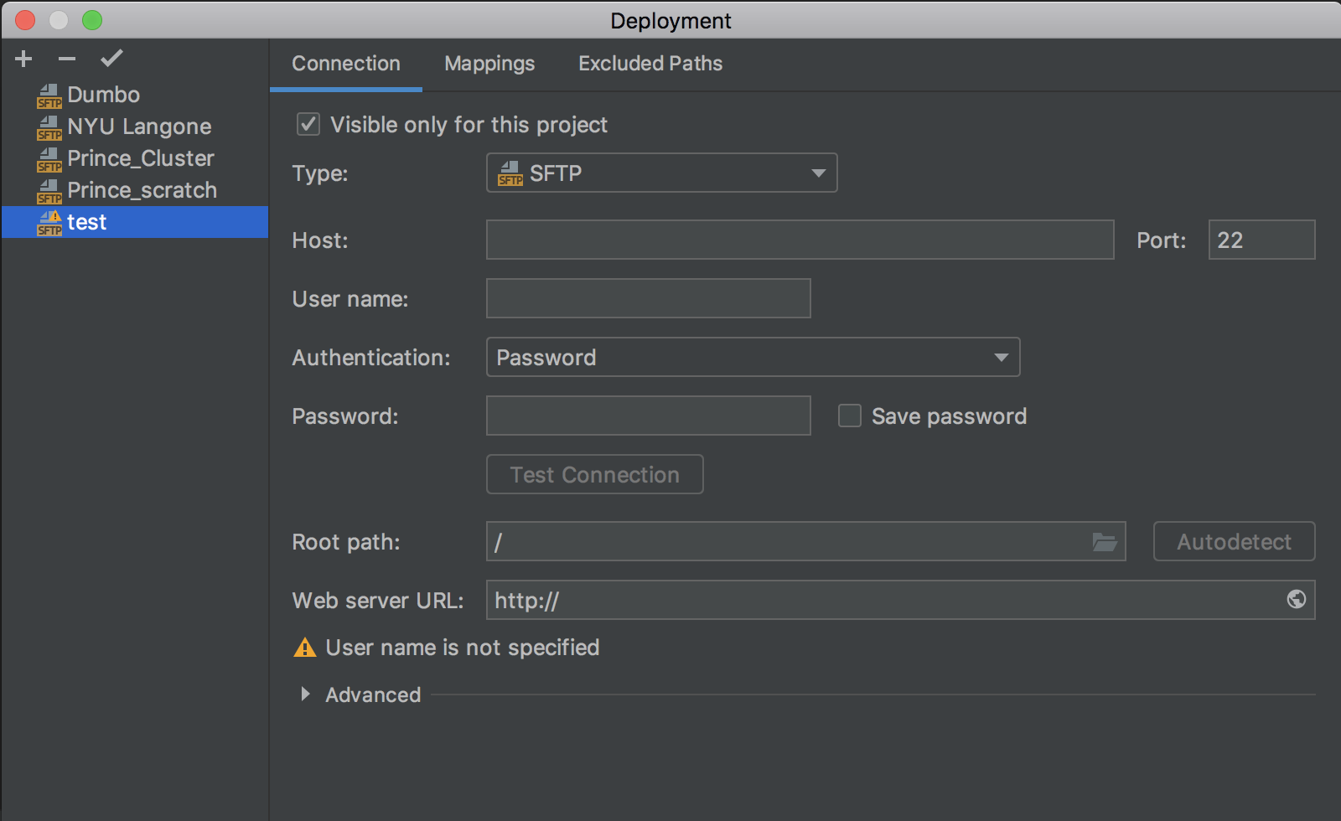

1. Click Browse Remote Host

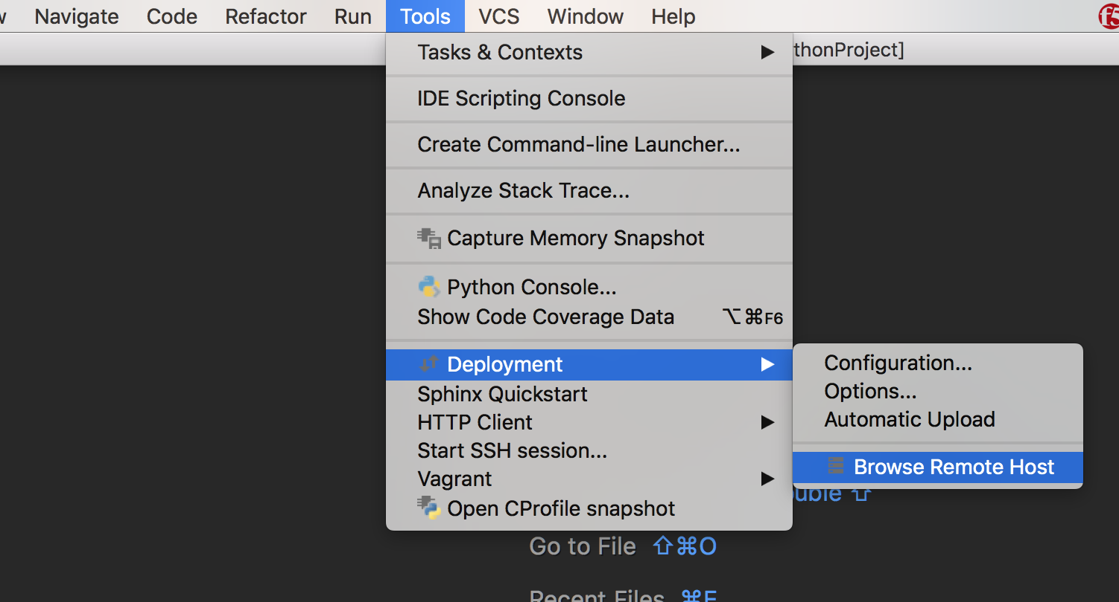

1. On the right side of screen, you will see this. Then you can view the file system on the server. You can also delete/copy/paste stuff from local to remote and vice versa

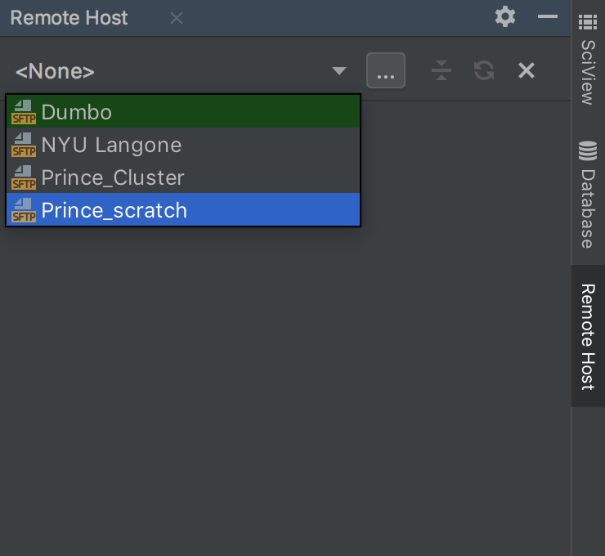

1. You can start a ssh session by one click.

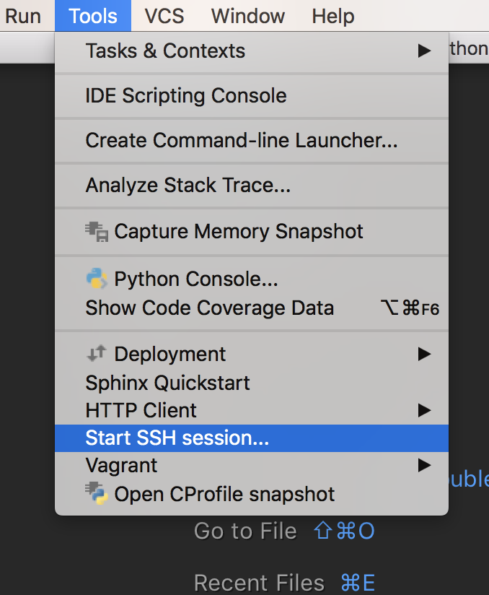

Note: other IDE such as VS code, sublime have similar function.